

**AUTOMATING LATHE MACHINE**

**27Th June 2017**

Table of contents

Introduction 2

Planning 3

Risk analysis 6

Virtualization 8

Calculations 8

Manufacturing Drawings for the Supports 11

Discussion and Conclusion 11

# Introduction

The objective of this report is to inform and update our lecturer on how our project of converting and *Old Manual Lathe in to CNC lathe* is going.

Our primary goal for the Semester 1 was to automate a ***Colchester Student 1800 Lathe*** that was originally completely mechanical. To complete this we decided that it was best to separate the work load. As a group we made a collective decision to split into three different groups. Each group specialized in their own field. Our groups consisted of Mechanical, Electrical and a Control Group.

Each group had their own tasks, mechanical students were tasked with the calculations of the forces and the selection of the ball screws. The electrical group was tasked with finding information about servo motors, switches, encoders and safety standards and also the selection of said parts. The control group assisted the other groups with research, calculations and selections.

# Planning

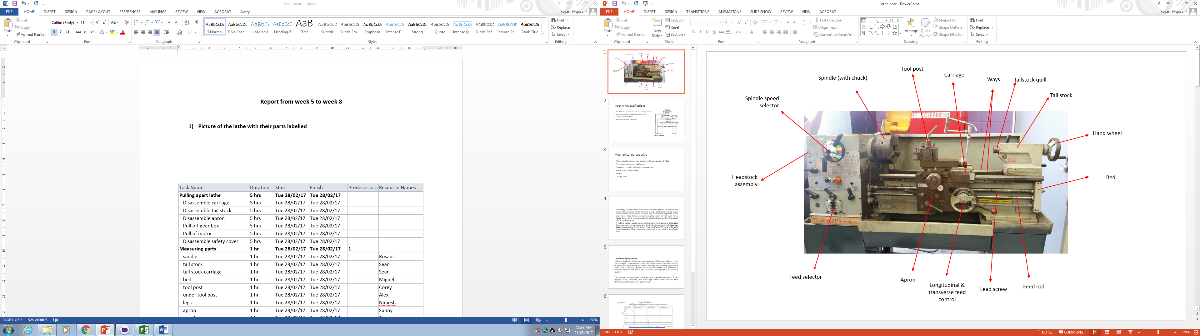

  
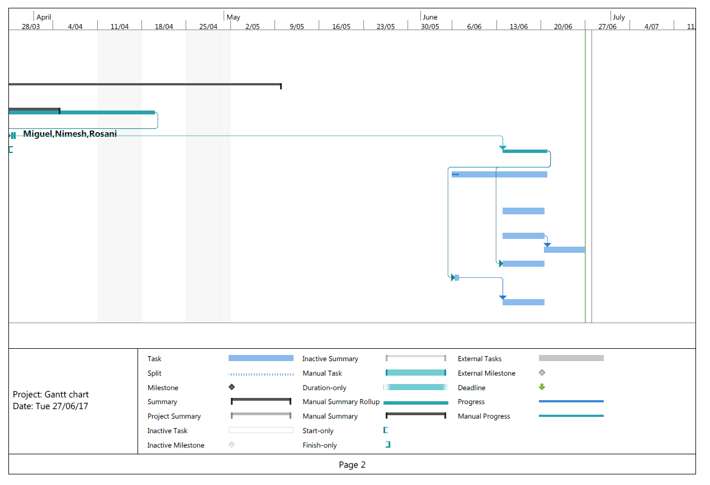

# Risk analysis

|  |  |  |  |  |  |  |  |  |
| --- | --- | --- | --- | --- | --- | --- | --- | --- |
| **Identify Hazards and subsequent Risks** | **Analyze Risks & Evaluate Risks** | | | **Identify and evaluate existing risk controls** | | | **Further Risk Treatments** | **Standards** |
|
| **Hazards/Issues/Risks** | **Consequence** | **Likelihood** | **Risk level** | **What we are doing now to manage this risk**. | **Effectiveness of our strategies** | **New risk level** | **Further action needed** |
| **Opportunities for improvement** |
| **MECHANICAL** | | | | | | | |  |
| Flying objects such as the chuck key left in chuck | 4 | E | H | Barrier between the workpiece and operator (Protective cover) | Reduces the risk of flying object | L | Voice control | AS 4024.1601-2006 4.6.1(a) , 6.1.3 AS4024.1-1996 (15.3.2.4) |
| Cutting tool injury when cleaning,  filing or polishing (machine off) | 1 | D | L | Risk sign. Authorization | Let people be aware of possible  risk | L | Training | AS 4024.1601-2006 6.3.5, .4.2. 10.2 |
| Metal chips and swarf coming loose | 3 | A | X | Barrier between the workpiece and operator (Protective cover) and the usage of PPE | Reduces the possibility of chips flying out of the machine | L | Voice control | AS 4024.1601-2006 4.6.1(a) |
| Rotating machine parts- entanglement | 5 | E | H | Machine stops when door is open (Mechanical sensor) | Prevent people from getting caught | L | Preventive action | AS 4024.1601-2006 4.6.1(a) AS 4024.1-1996 (15.3.2.3) |
| Closing movements of parts under  power can result finger trapping | 4 | C | X | Machine stops when door is open (Mechanical sensor) | Prevent people from getting caught | L |  | AS 4024.1601-2006 4.6.1(a) AS 4024.1801-2006 |
| Work pieces can very hot | 2 | D | L | Monitoring coolant flow | Assure coolant is running at all time | L | PPE |  |
| Contact with cutting fluids, oil and grease can irritate skin | 1 | B | M | PPE | Prevent skin from contacting fluids | L | PPE | AS 4024.1601-2006 6.1.4 AS 4024.1-1996 (15.4) |
| Swarf can jam the machine or be  ejected if allowed | 1 | E | L | Power protection | Neither motor nor swarf jam have contact with the operator | L | - |  |
| Eye injury | 4 | D | H | Barrier between the workpiece and operator (Protective cover) | Reduces the risk of flying object | L | PPE | AS 4024.1601-2006 4.6.1(a) |
| **ELECTRICAL** | | | | | | | |  |
| Electrocution | 5 | E | H | Check all cables before turning on lathe | Reduce the likelihood of Electrocution | M | Install RCA | AS/NZS 3000:2007 |
| Electric shock | 4 | E | H | Check all cables before turning on lathe | Reduce the likelihood of Electric shock | M | Install RCA | AS/NZS 3000:2007 appendix L |
| Soldering Iron Burns | 2 | C | M | Check the heat from the lathe and training | Lower the risk of damage to person | L | Use Common sense |  |
| Proximity Switch Failure | 3 | D | M | Test switches with lathe off | Assure the function of the switches and replacement of broken switches | L | Recheck switches periodically | AS/NZS 3000:2007 (7.2.2.2) |
| Safety Switches Failure | 3 | D | M | Test switches with lathe off | Assure the function of the switches and replacement of broken switches | L | Recheck switches periodically | AS 4024.1.-1996 (15.3.2.8) |
| Catastrophic Lathe Failure | 4 | E | H | Add an safety stop button | Allows the operator to stop the lathe before catastrophic injury happens | M | PPE | AS 4024.1.-1996 (15.3.2.8) |

# Virtualization

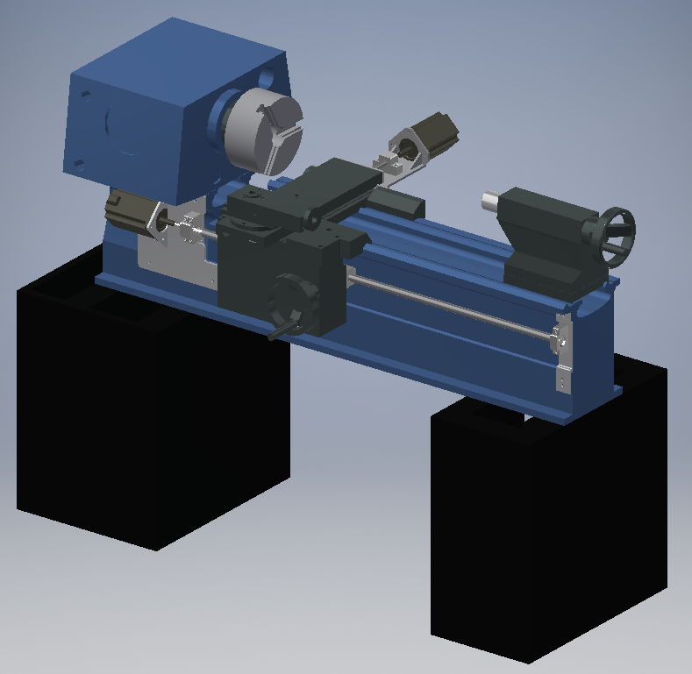

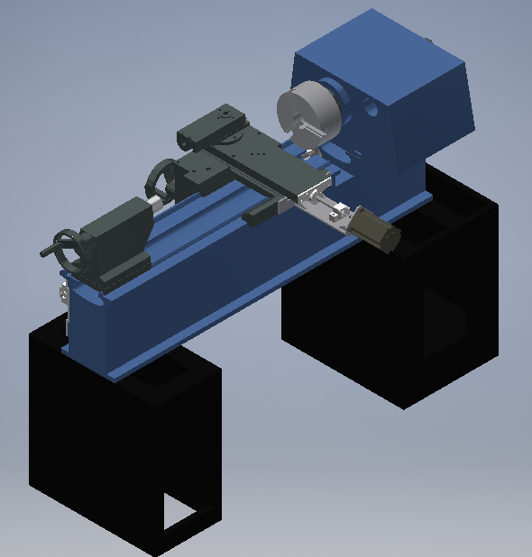

# Calculations

Calculate torques and forces exerted by the lathe to be able to select both motors and ball screws.

Initial stablished parameters:

|  |  |  |
| --- | --- | --- |
| Predominantly material for workpiece | High Carbon Steel | N/A |
| Depth of cut (max) | 6 | mm |
| Feed rate (max) | 0.5 | mm/rev |
| Chuck angular velocity (max) | 22 - 1800 | RPM |
| Coefficient of friction metal-metal | 0.16 | N/A |
| Z-axis weight | 50 | Kg |
| X-axis weight | 25 | Kg |
| Manual angular velocity | 120 | RPM |
| Lead angle accuracy | 0.05 | mm |
| Ball screw length to be used for the Z-axis | 1100 | mm |

CNC lathe is required to be driven by ball screws and servo motors for their lowest factors of frictions and accuracy respectively. Therefore all following calculations are aimed at selecting a ball screw and a servo motor which can overcome torque, velocity and forces developed by the lathe.

For cutting force calculation:

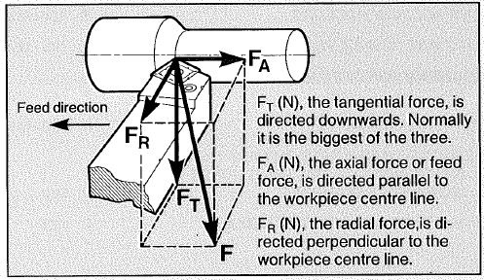

The approximate relationship of these components to each other is:

Tangential cutting force () may be determined by:

Where = specific cutting force (N/mm2)

a = depth of cut (mm)

s = feed (mm/rev)

As = 2300 N/mm2 for a workpiece of high carbon steel, it need to be corrected by three (3) factors which are insert geometry, entering angle of the tool and the feed rate chosen

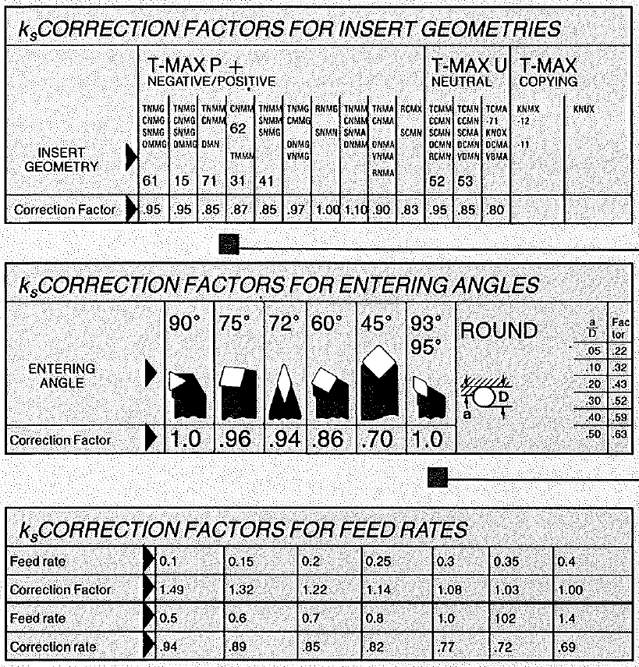

Researched ball screws, the formula need and using this calculated the ball screws needed for our lathe

With these two formulas and also the breakdown of our forces and determining the cutting forces (produced by Miguel) we were able to obtain the toque on the ball screws

For the z-axis or The Apron we got a total force of **4632.5N**

Then using the above ball screw formula we get **8.2Nm**

And apply the safety factor we obtain the final **10.9Nm**

**Repeating this method for the x-axis or tool post**

We get for total collective force which makes our ball screw torques **5.1Nm** which makes it **6.8Nm** with a safety factor.

## Manufacturing Drawings for the Supports

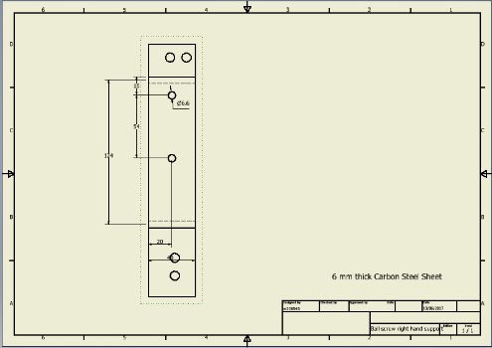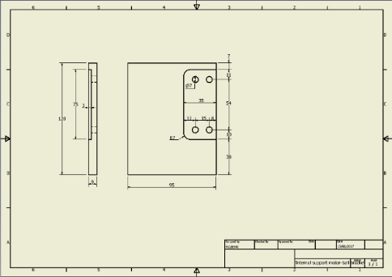

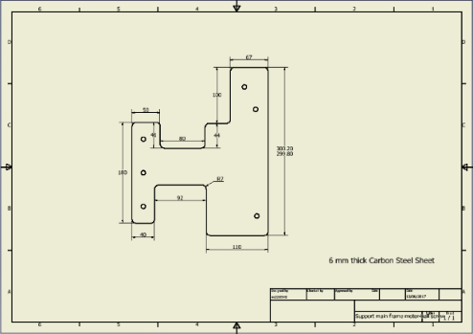

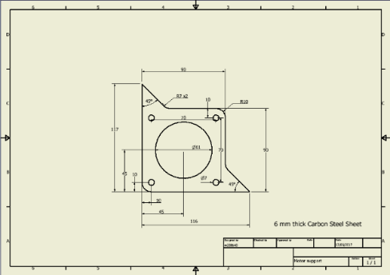

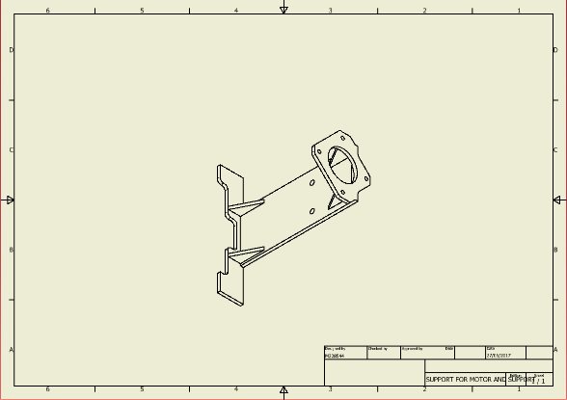

# Discussion and Conclusion

The task that was given to us was to automate the Colchester Student 1800 from being completely mechanical to be able to work through a computer numerical control or CNC. We were tasked with many different tasks along with disassembling the lathe, managing the project, ordering and selecting parts and so on.

During the Term 1 of Semester 1 we managed to accomplish quite a lot of things such as:

* Disassembling the Lathe was our first main priority.
* Each Student must select a part and individually draw it in a 3D program called “Inventor:
* Setting up Project Manager and Gantt Chart
* Bill of Materials (BOM)
* Started on creating Lathe Model
* Calculations of the forces

Dismantle the lathe was our main priority and it took us around 2 weeks to fully complete which didn’t include gearbox and so on, this is when we started to select our individual parts to draw. Along with selecting our parts we also started to manage our project, setting up Project Manager and our Gantt chart which we strictly tried to follow but due to our lack of experience and time management we fell behind slightly. Setting up the Project Manager and Gantt chart took us a few weeks before we were able to get familiar with it. One of the team members Rosani did all of the management and further updated both the Project Manager and Gantt chart. By the end of week 5 we started to collect our lathe parts and slowly assemble them, however we started to run into issues of parts not fitting together hence why we had to redraw most of the parts so that they fit together properly which moved into term 2. The calculation of the forces was mostly dealt by Miguel which everyone tried to help with in any way they can. Closer to the end of the Term 1 we set up the Bill of Materials which had rough estimates and quotes from different companies.

During the Term 2 of Semester 1 we achieved more than we did during Term 1. These are the things we’ve done:

* Selection of Ball Screws
* Design of Supports for Ball Screws / Motors
* Full Working Lathe Model
* Ordered the Parts for the Lathe
* Disassembling of the lathe even further
* Sending the Lathe for Paint

Taking off from Term 1 we have started to work on the full lathe model even further, we discarded parts that we didn’t need in our model and further improved parts that needed to be replaced. From this model it was possible for us to start looking at different types of ball-screws that will fit in our system and that will work in our system. We found a website that provided custom made ball screws and the ball screw supports at THK website but under the standard of NSK. On the website they had custom 3D models of both the support and ball screws that we able to fit into our Final Lathe model. Having said that our full lathe model was in working condition. It had all of the correct constraints, dimensions and etcetera. Having a working model we were able to finalize our ball screw selection and order them from NSK. After this was completed we started disassembling the lathe gearboxes and parts that will not be necessary in our final CNC Lathe. During our time off during Term 2 Ross will send the Lathe off for Paint and wait for other parts to arrive.

In conclusion during the Semester 1 we were able to successfully design a 3D lathe model along with ordering most of the parts that are necessary to make it function. Our primary goal for Semester 2 will be manufacturing support brackets and putting the lathe back together with the acquired parts along with writing code for our Logic Board.